**TEST REPORTS FOR PROVIDER FINDER AND NETWORK LOOKUP**

**TEST CASES USING JUNIT:**

TEST CASES FOR LOGIN MICROSERVICE:

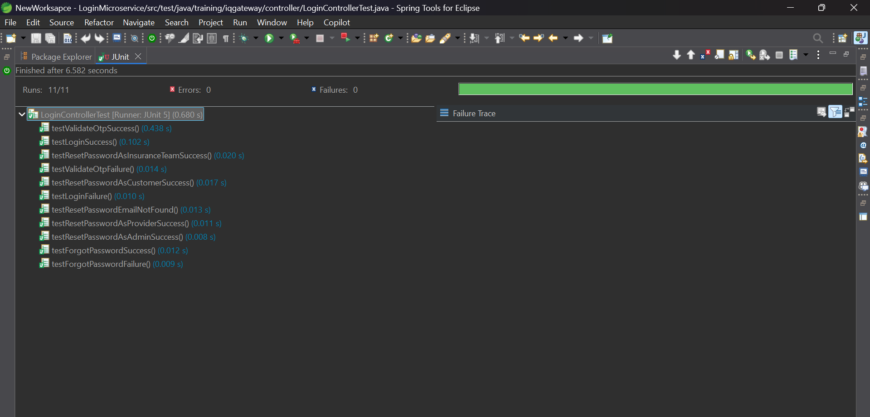

TEST CASES FOR PROVIDER MICROSERVICE:

Provider Controller:  
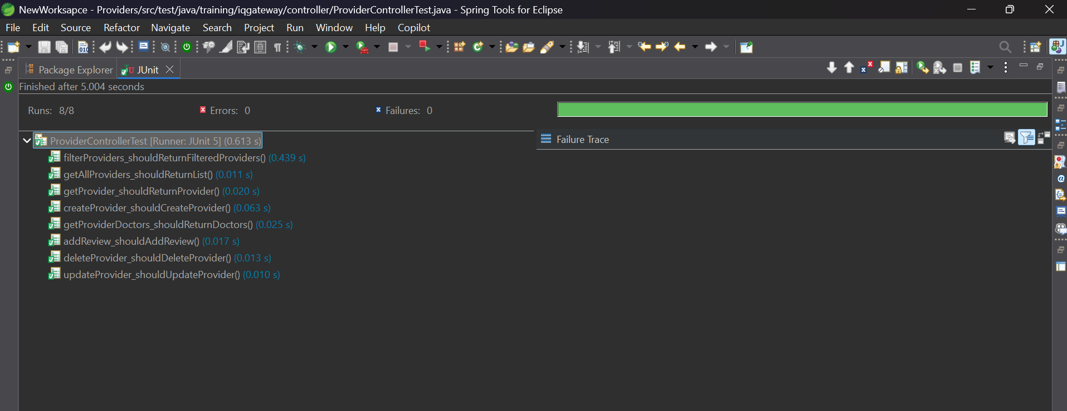

TEST CASES FOR Customer MICROSERVICE:

Customer Controller:  
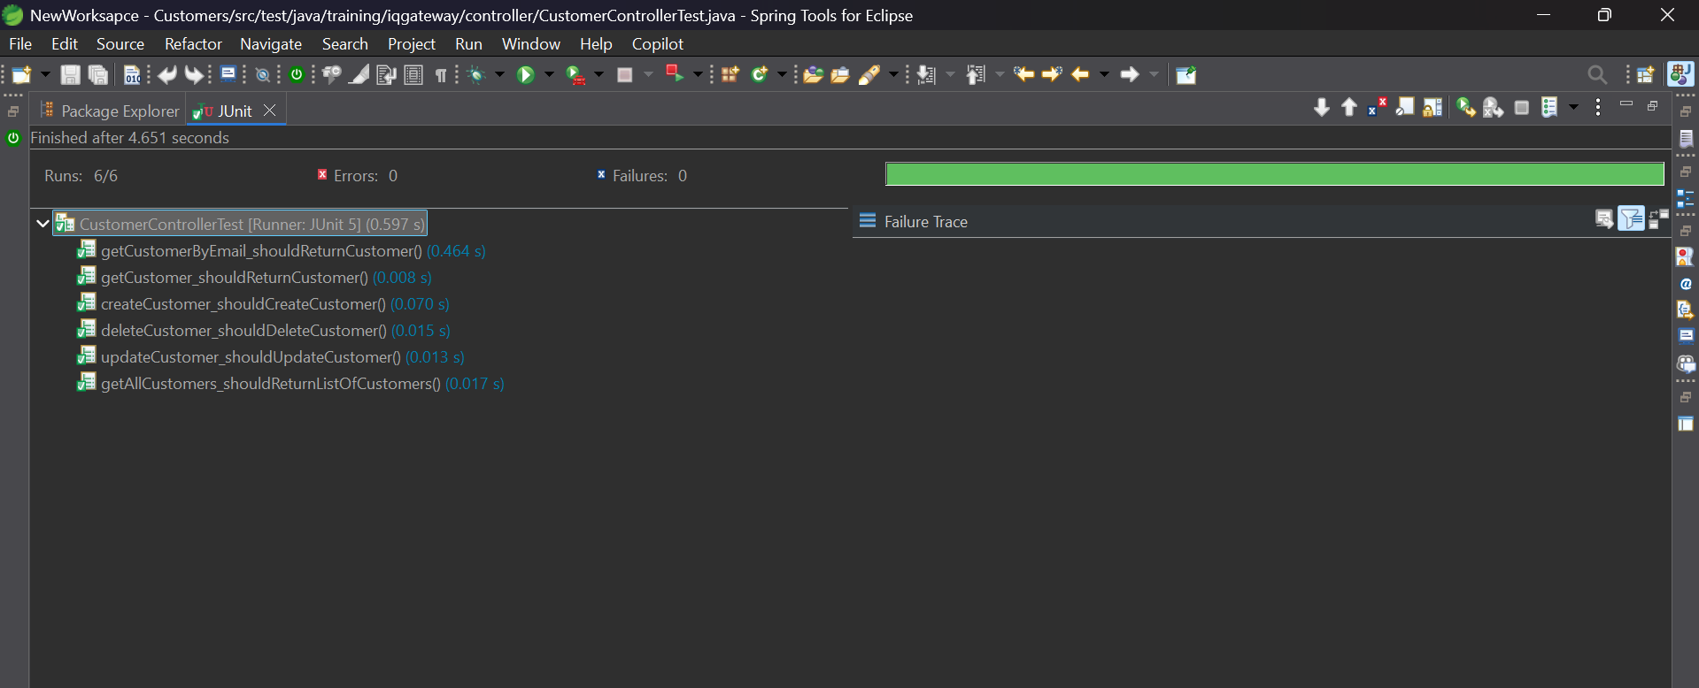

CustomerProvider Controller :

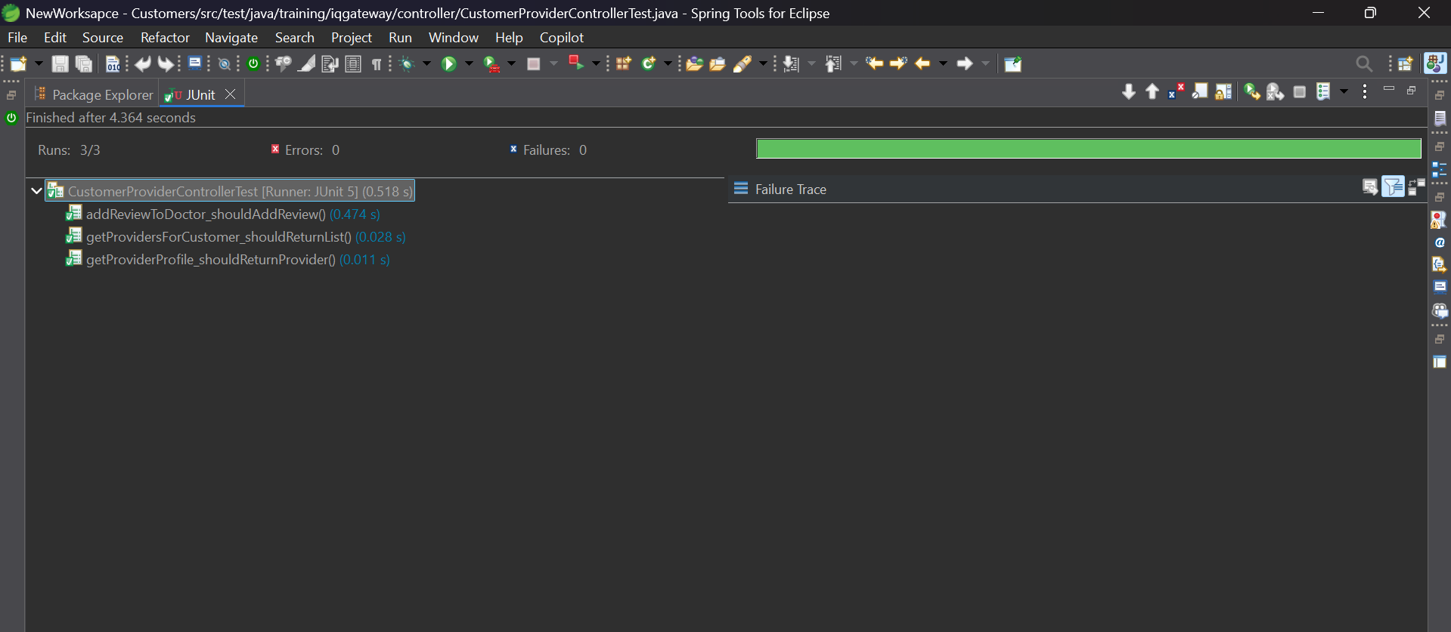

CustomerDoctor Controller :

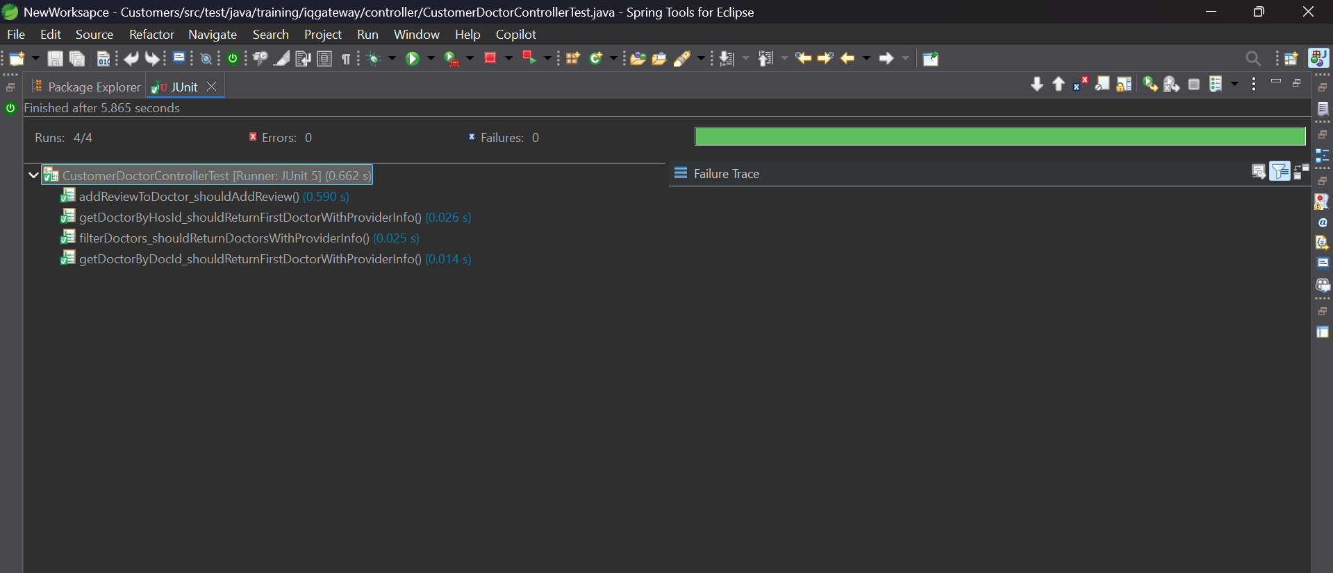

Notification Controller :

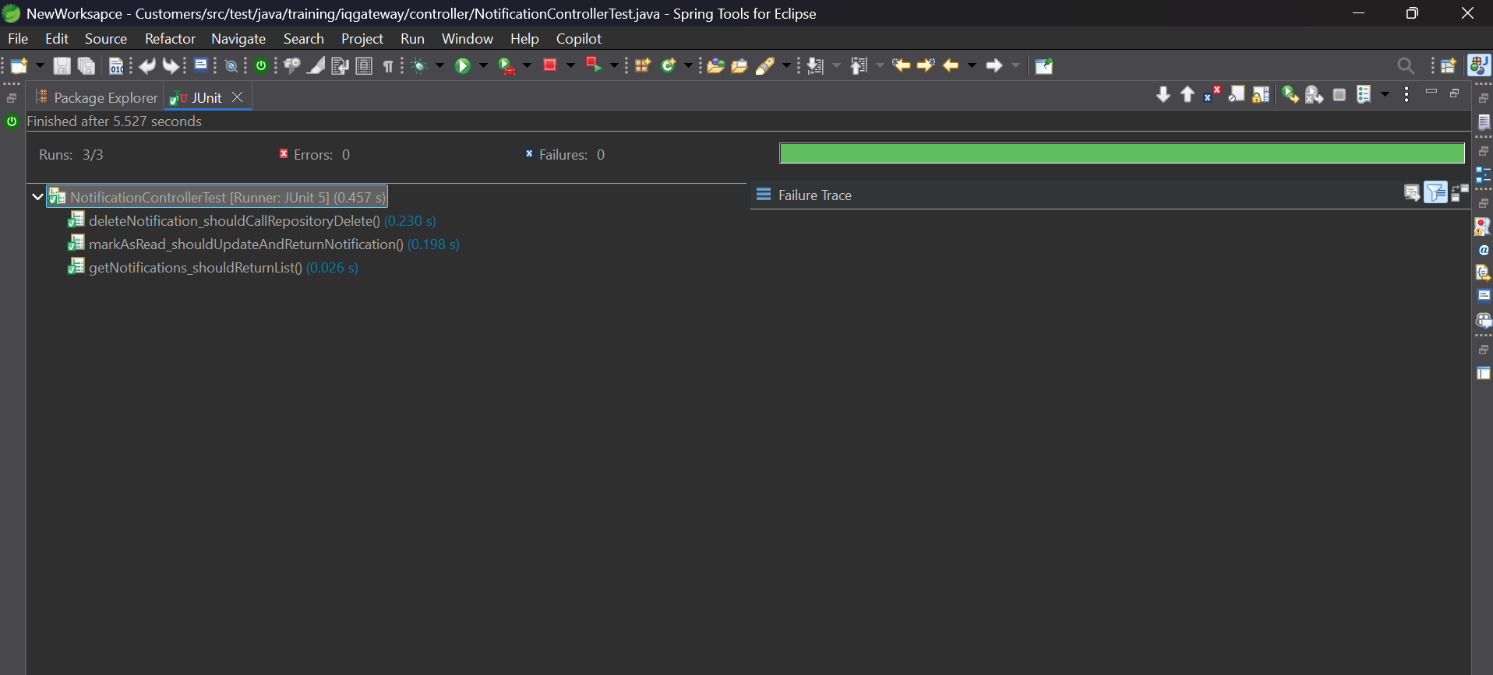

TEST CASES FOR DOCTOR MICROSERVICE:

Doctor Controller:

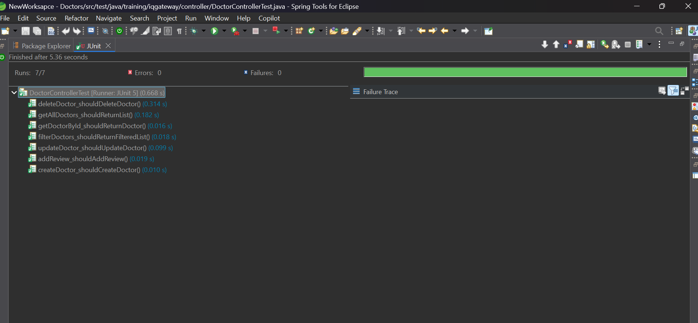

TEST CASES FOR INSURANCE_TEAM MICROSERVICE:

InsuranceTeamCustomer Controller :

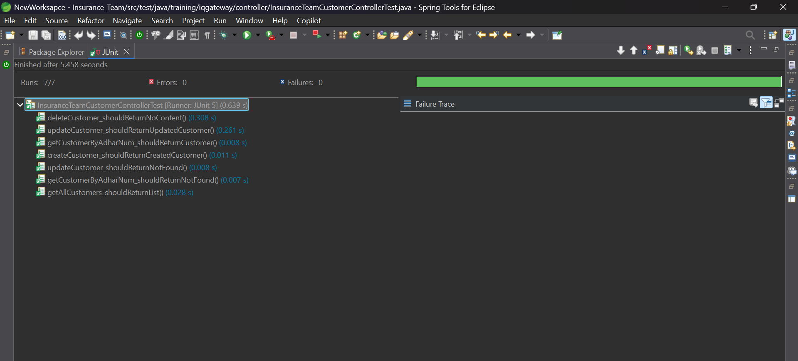

InsurancePlans Controller :

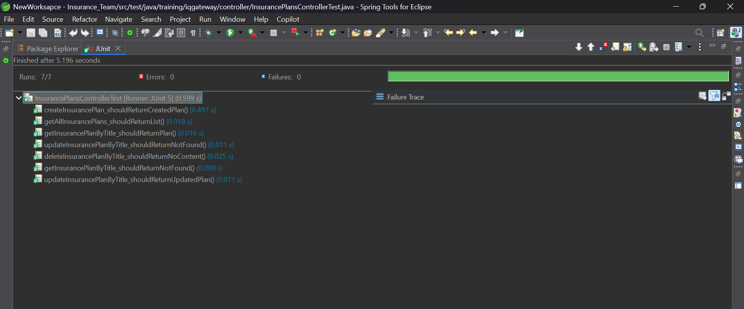

TEST CASES FOR ADMIN MICROSERVICE:

Admin Controller :

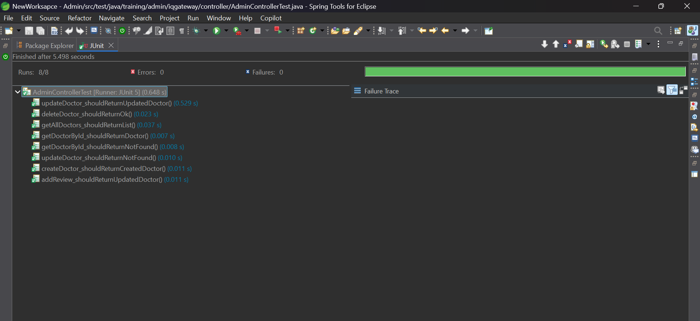

AdminProvider Controller :

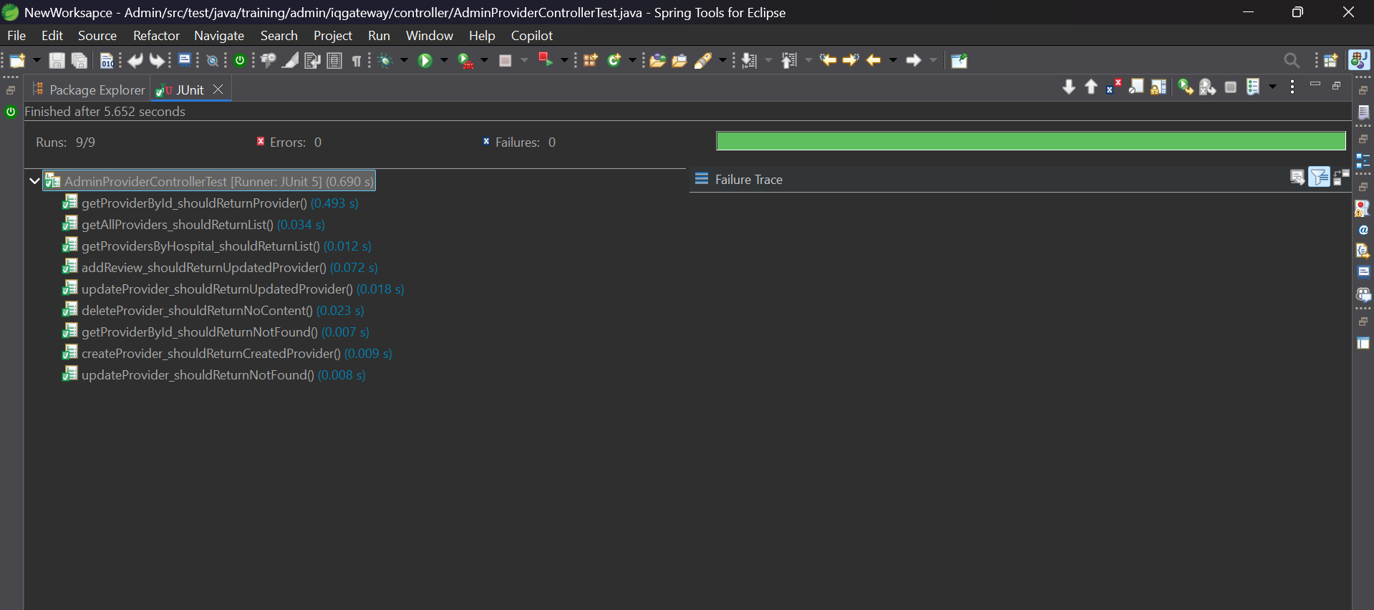

SWAGGER TEST:

LOGIN MICROSERVICE:

LoginController:

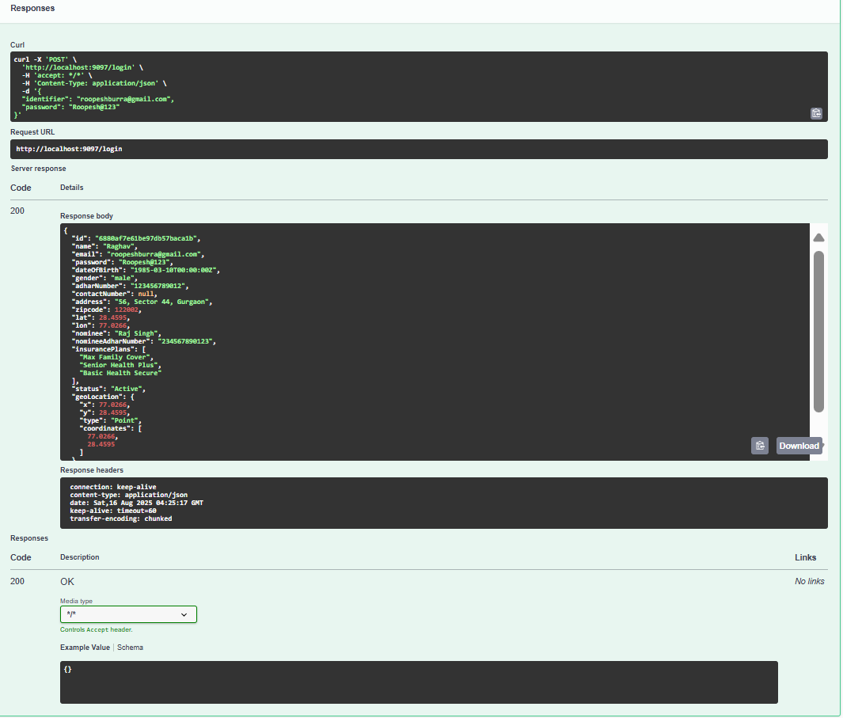

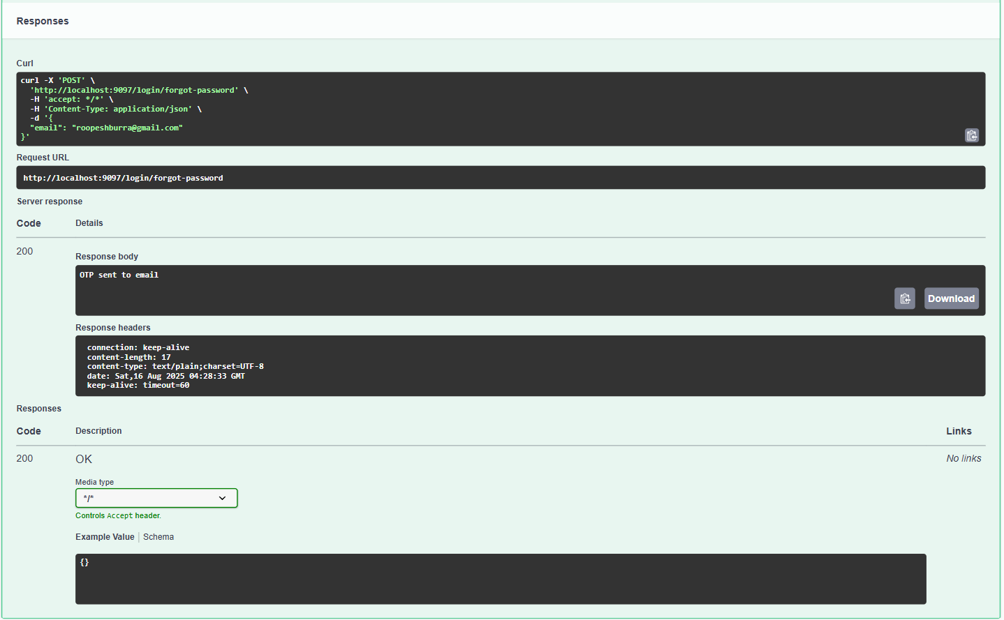

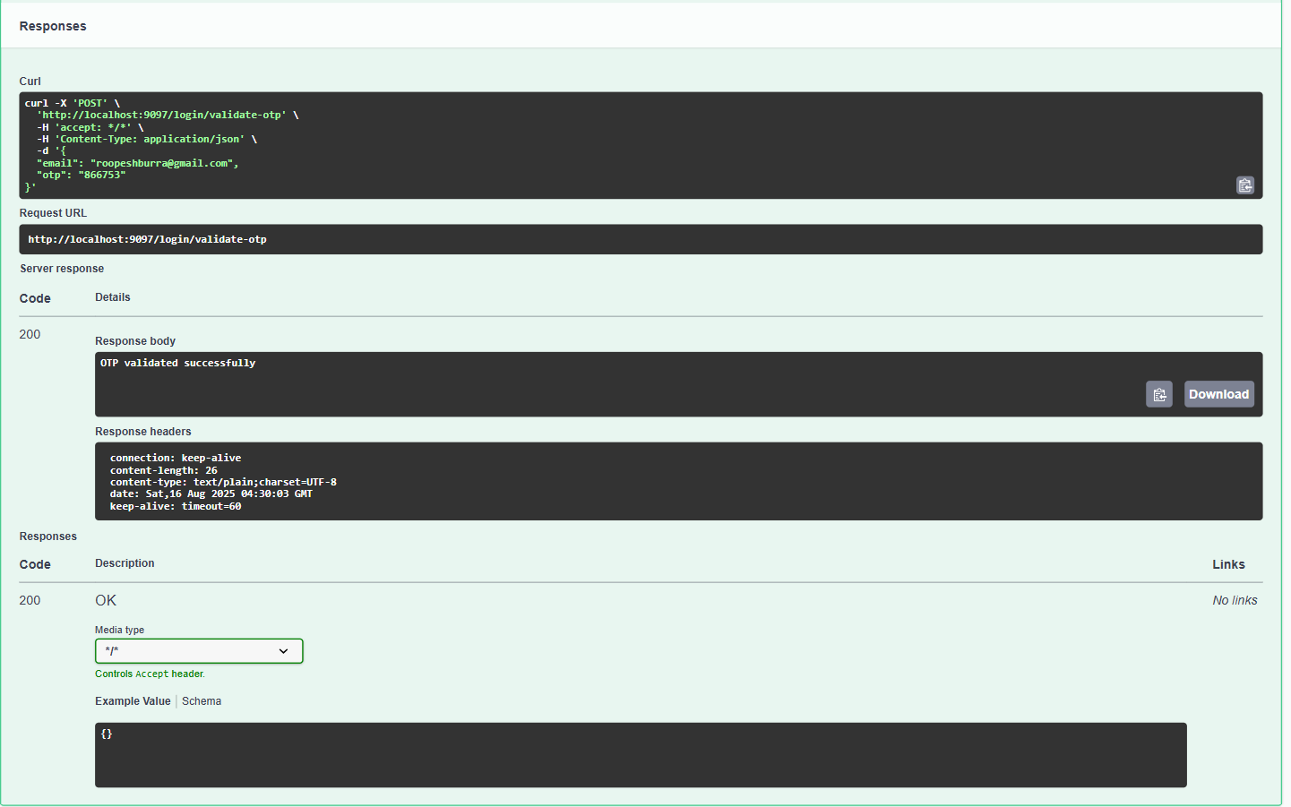

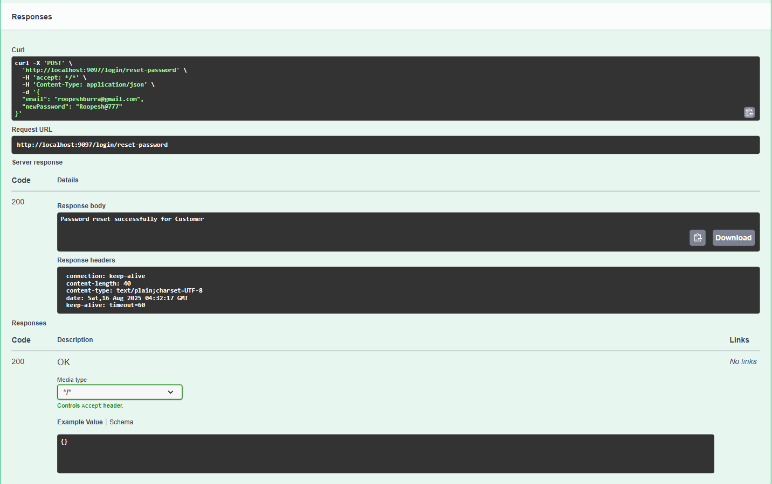

Provider MICROSERVICE:

Provider Controller :

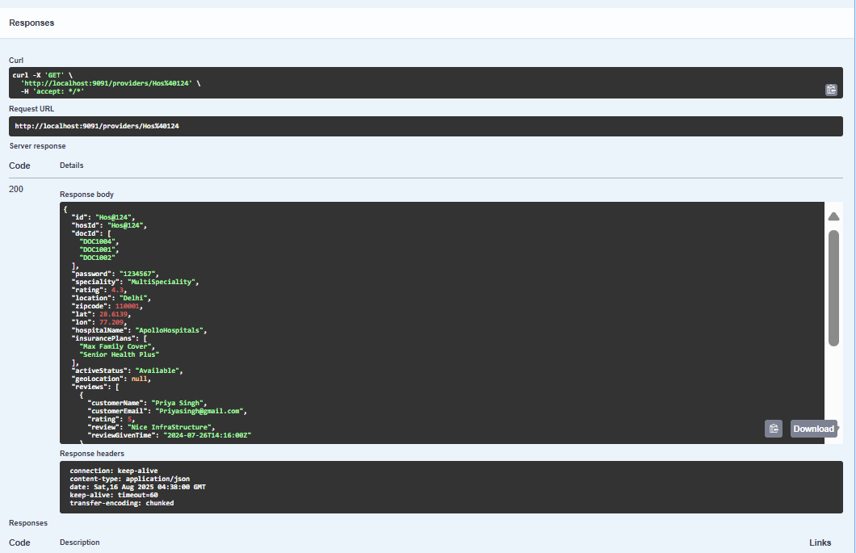

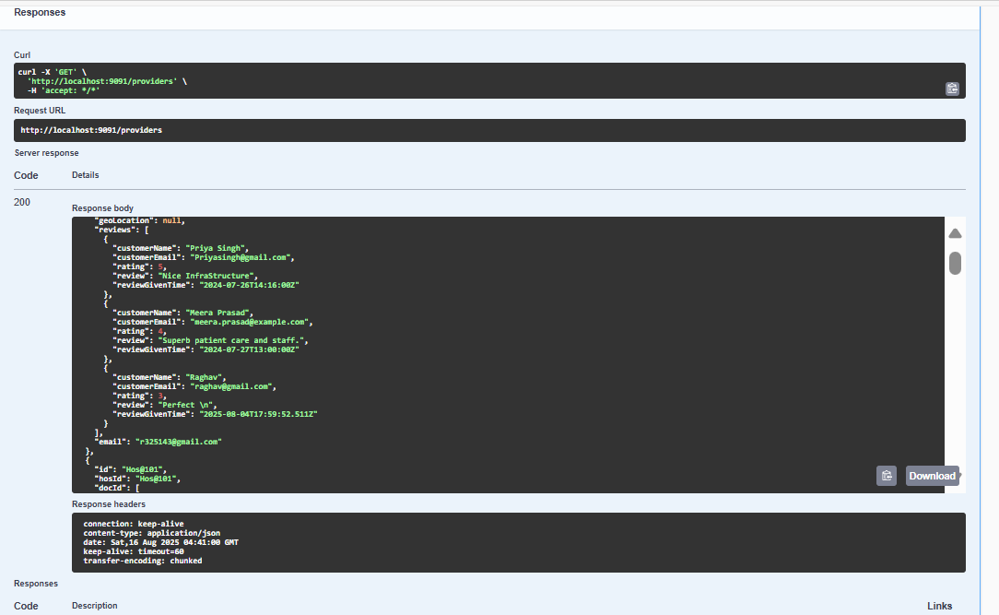

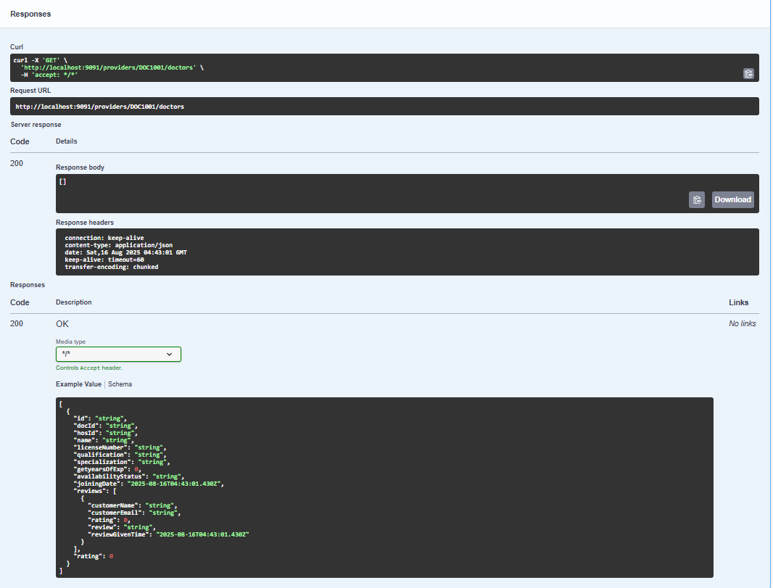

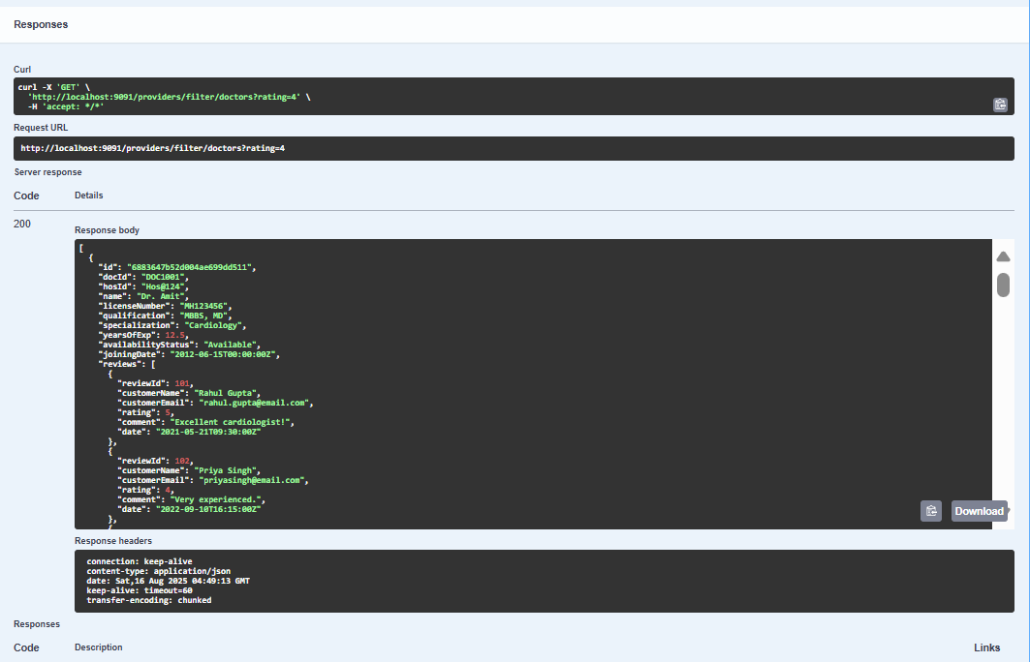

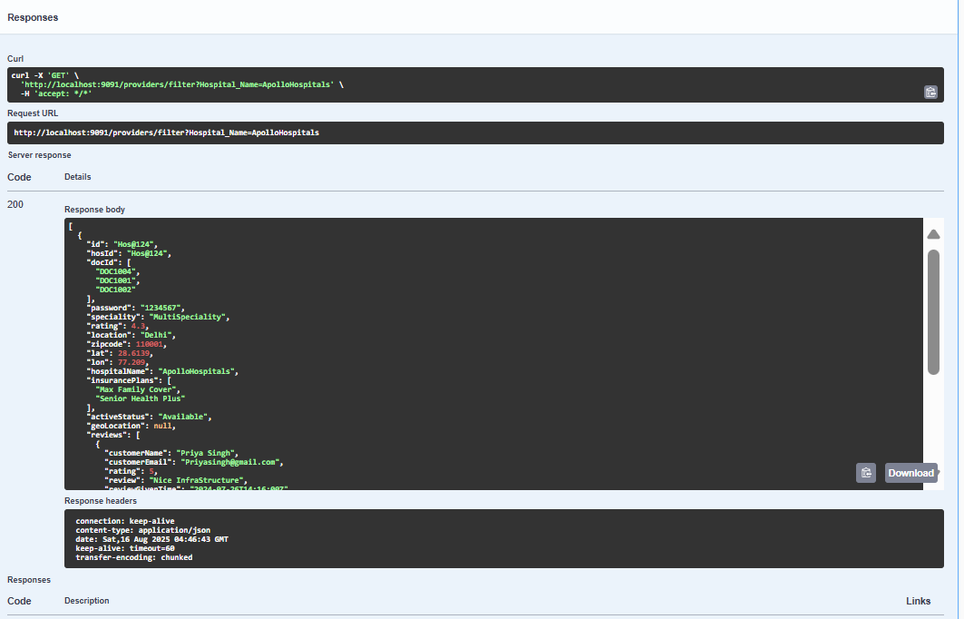

Doctor MICROSERVICE:

Doctor Controller :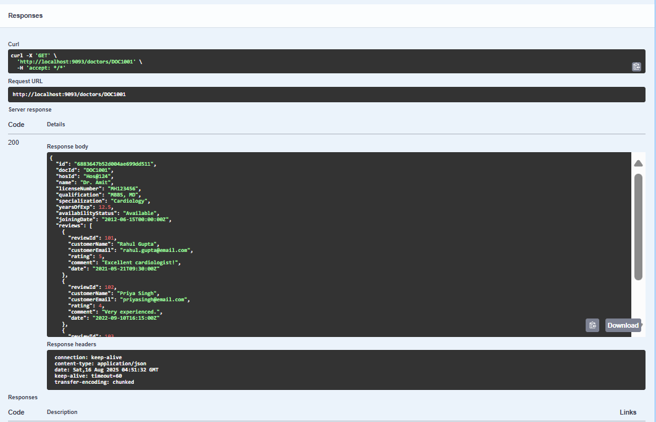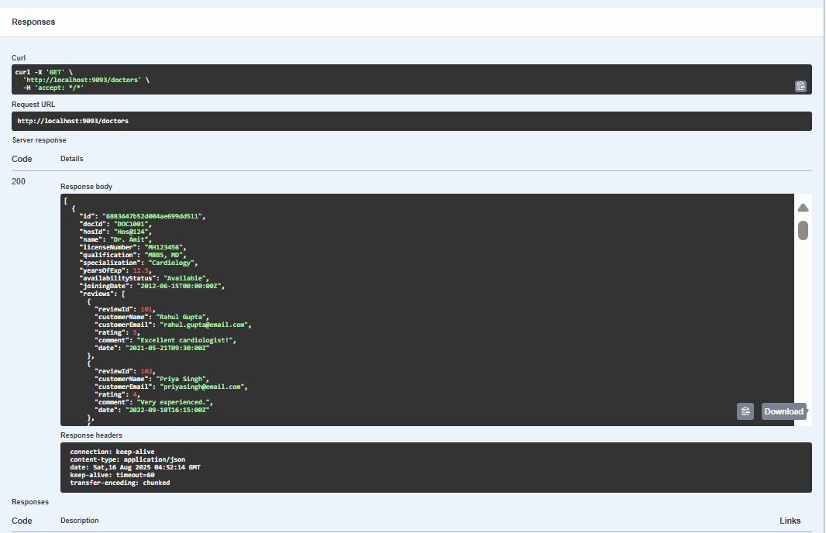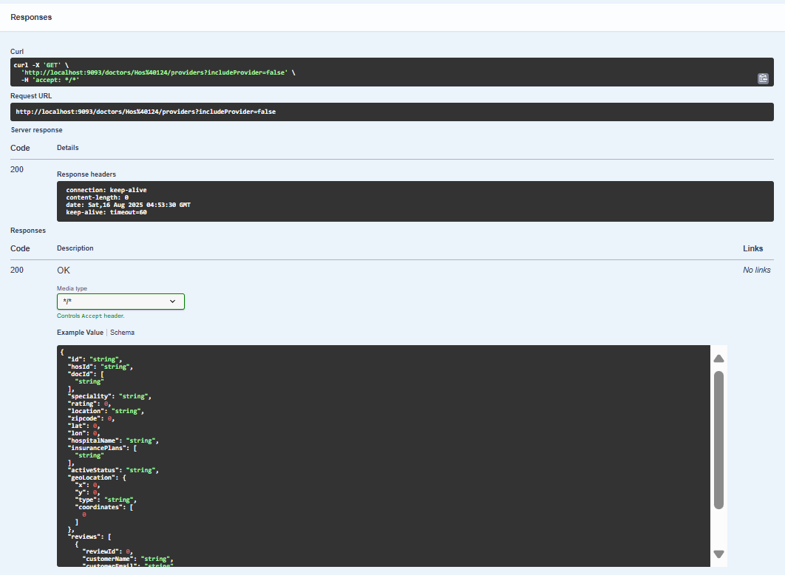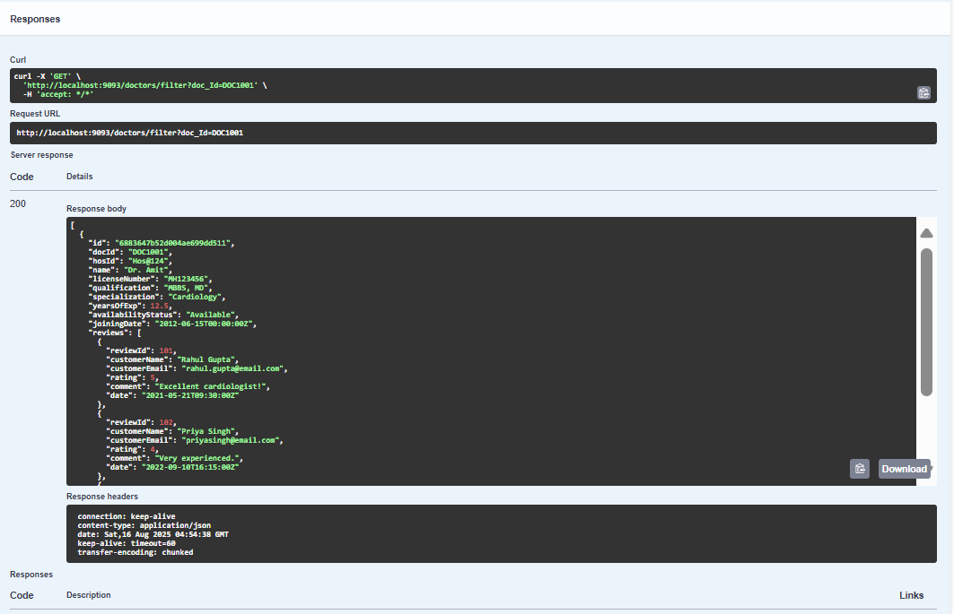

Customer MICROSERVICE:

Notification Controller :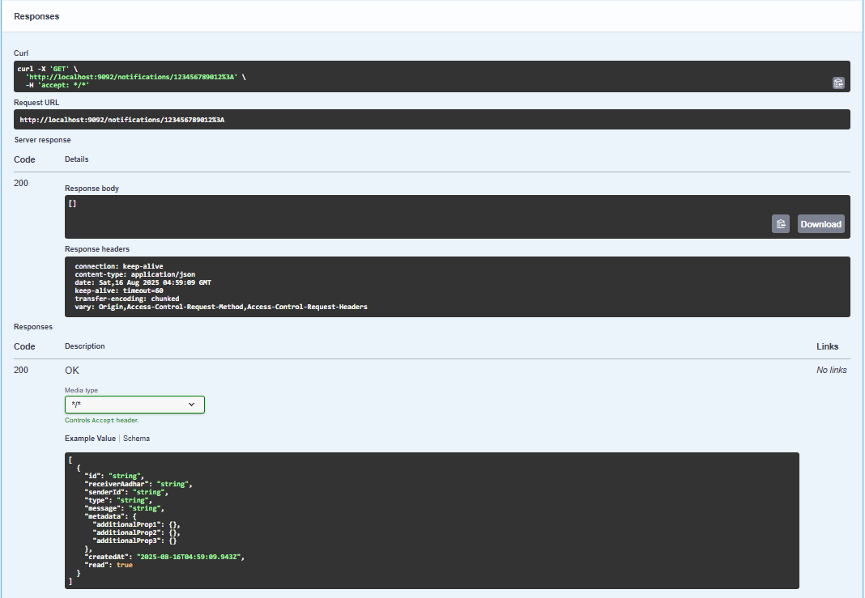

Customer Controller :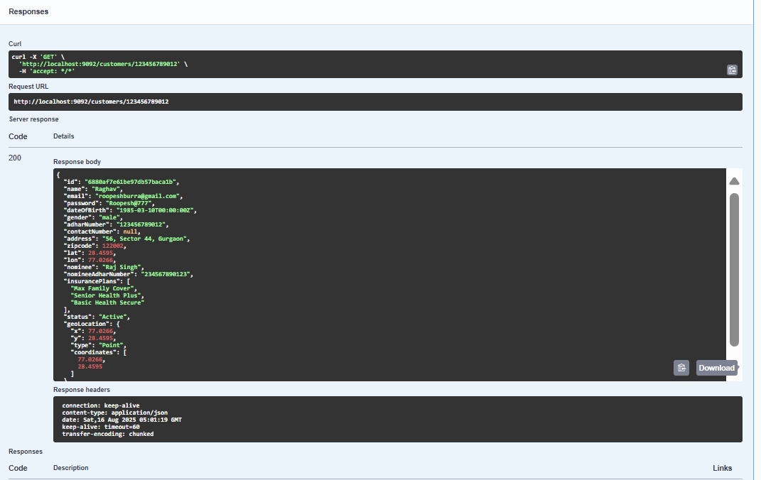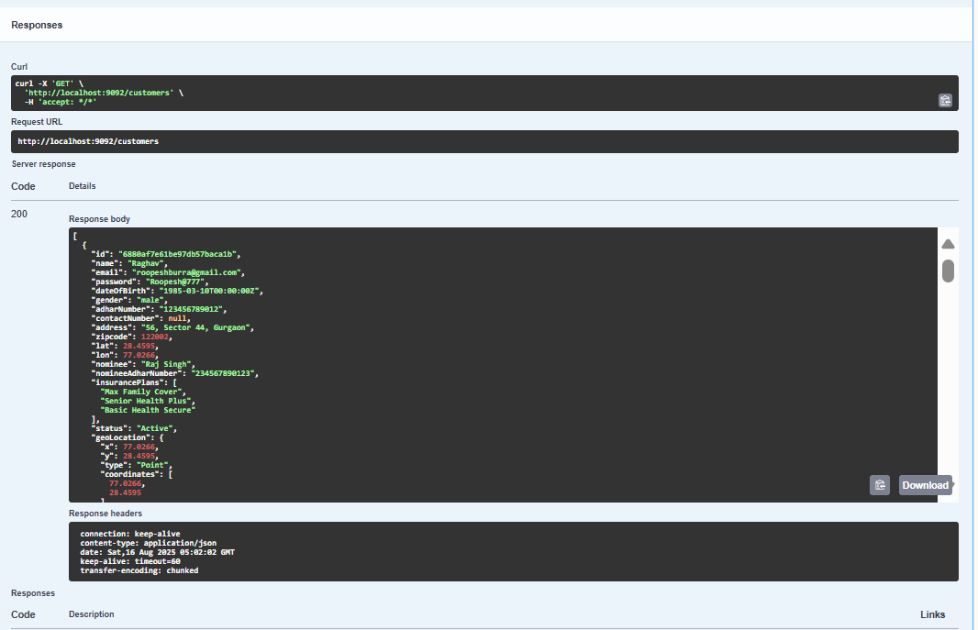

CustomerProvider Controller:

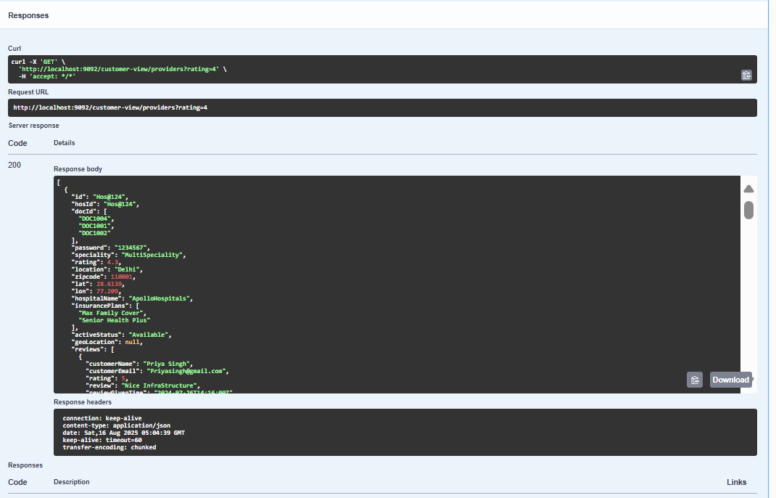CustomerDoctor Controller :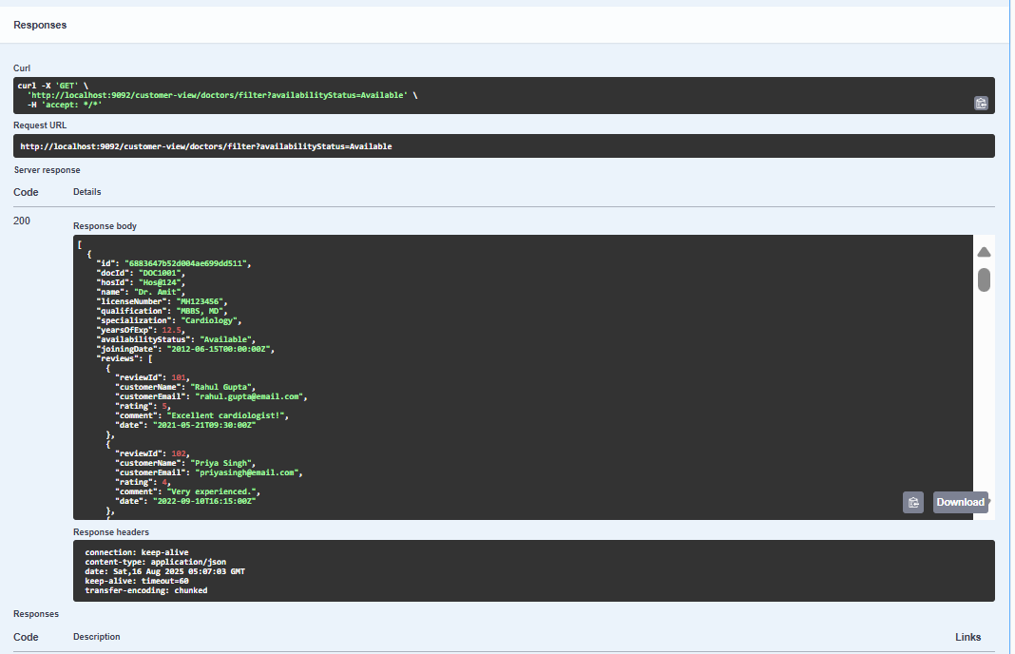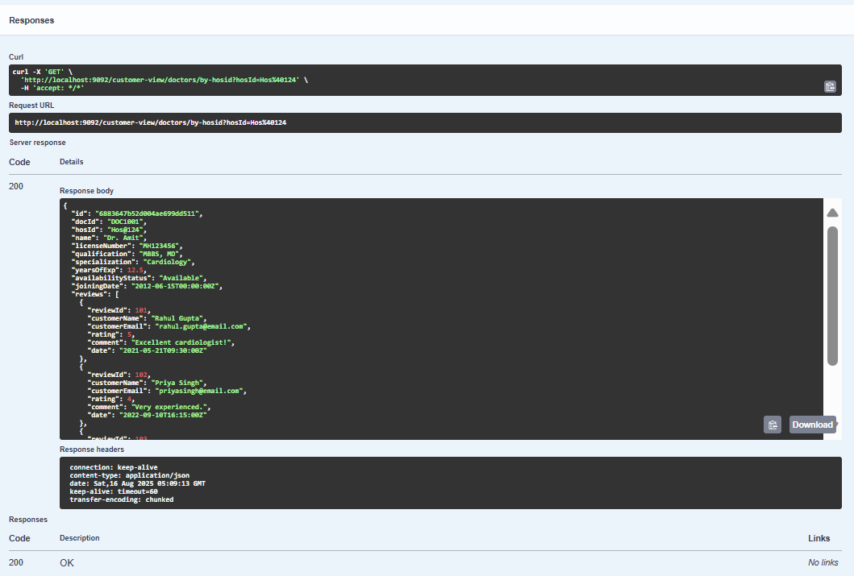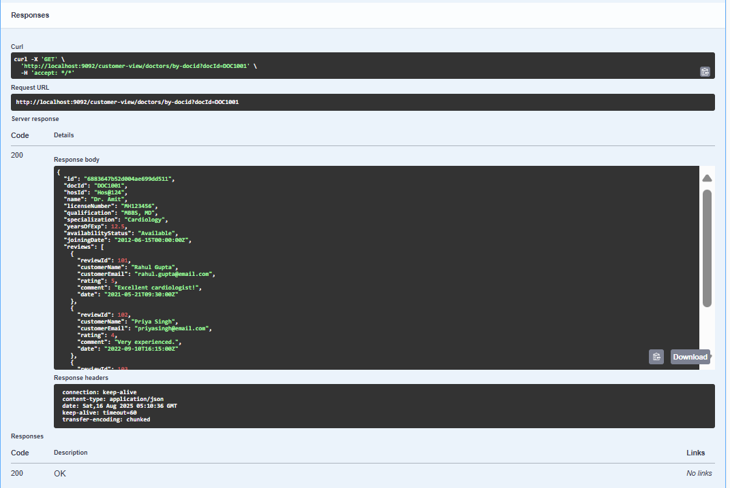INSURANCE_TEAM MICROSERVICE:

InsuranceTeamCustomer Controller :

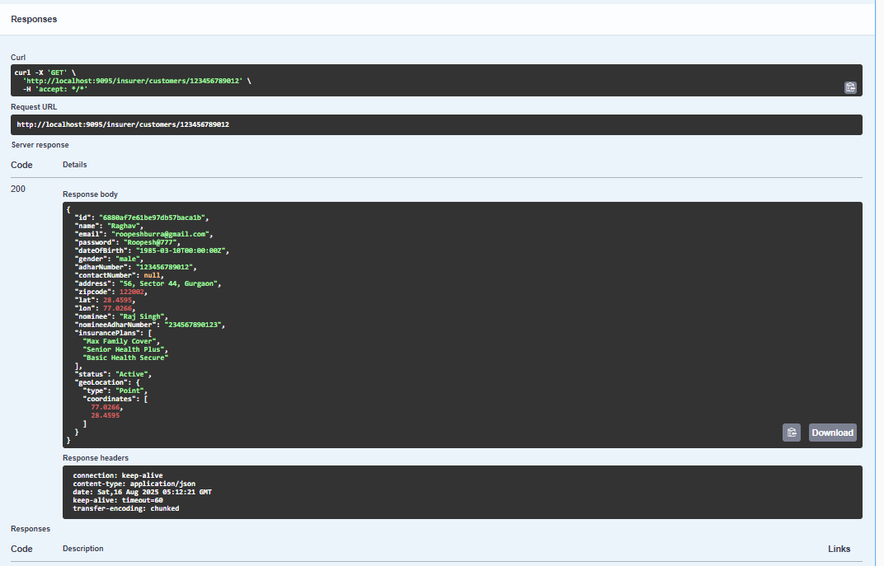

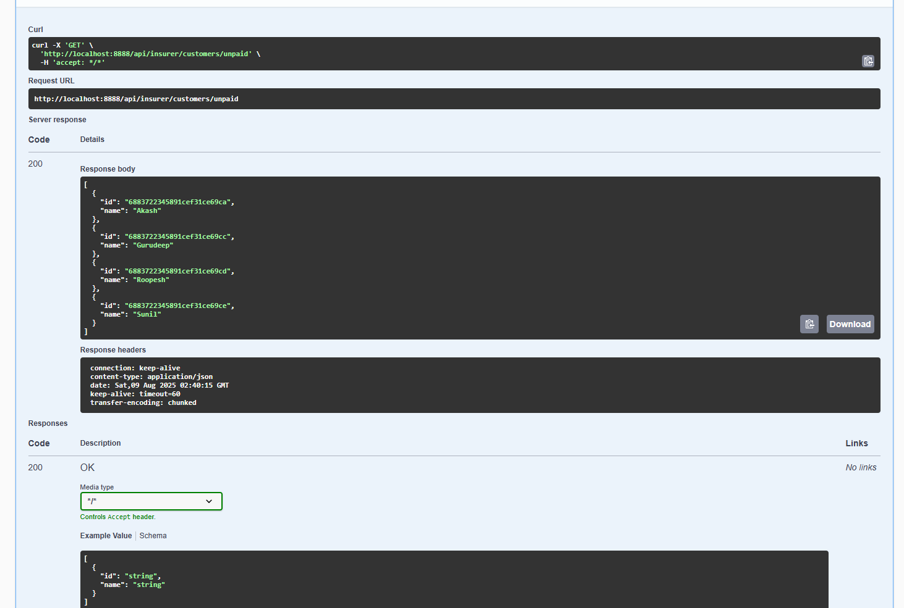

INSURANCE_TEAM MICROSERVICE:

InsurancePlans Controller :

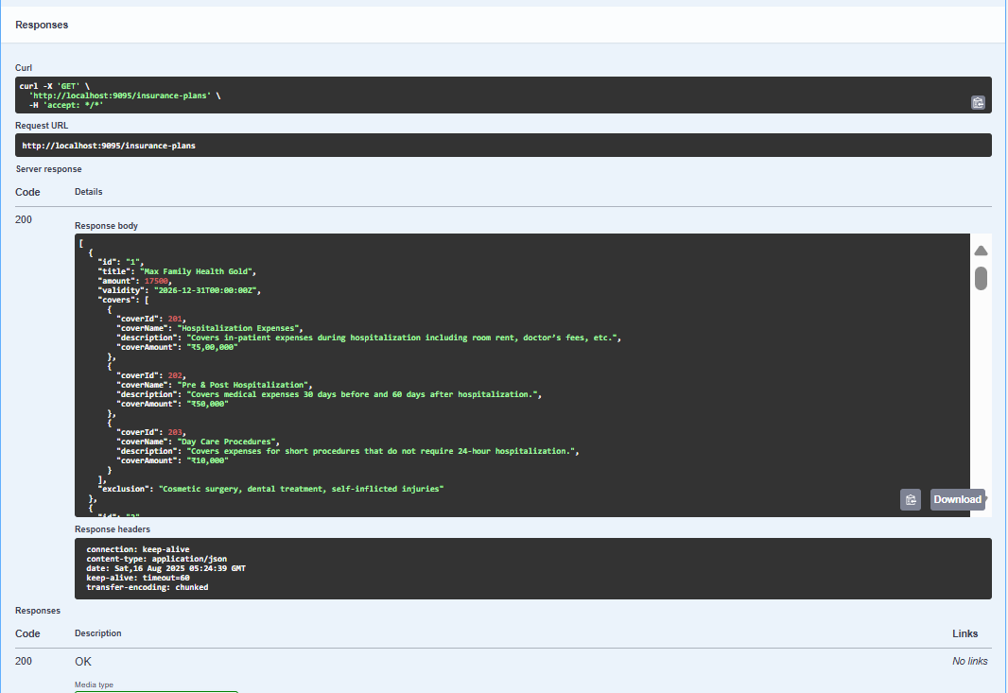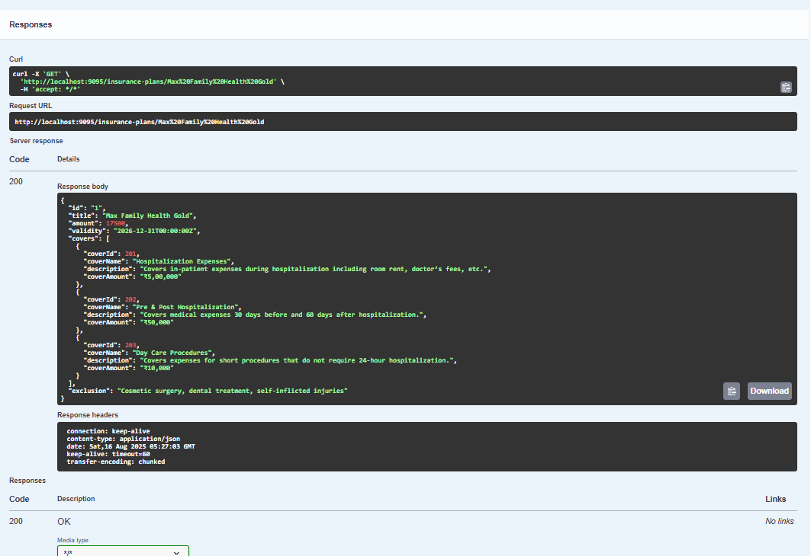

-----------------------------------------------------------------

ADMIN MICROSERVICE:

AdminController: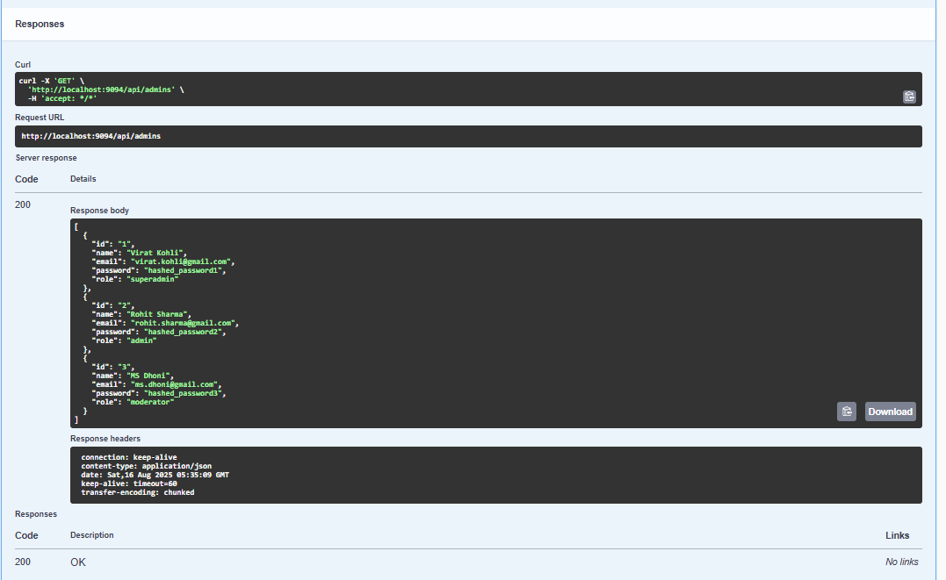

AdminProvider Controller :

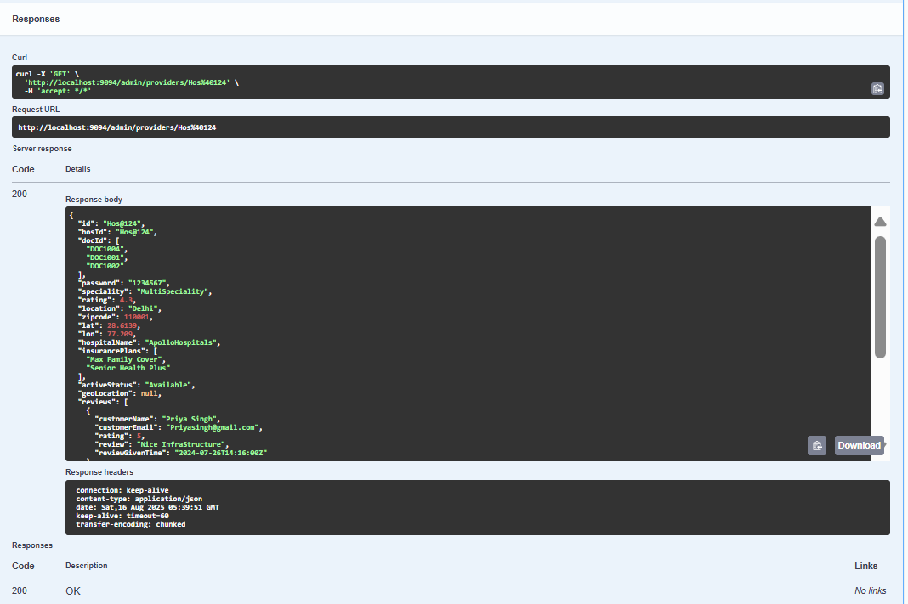

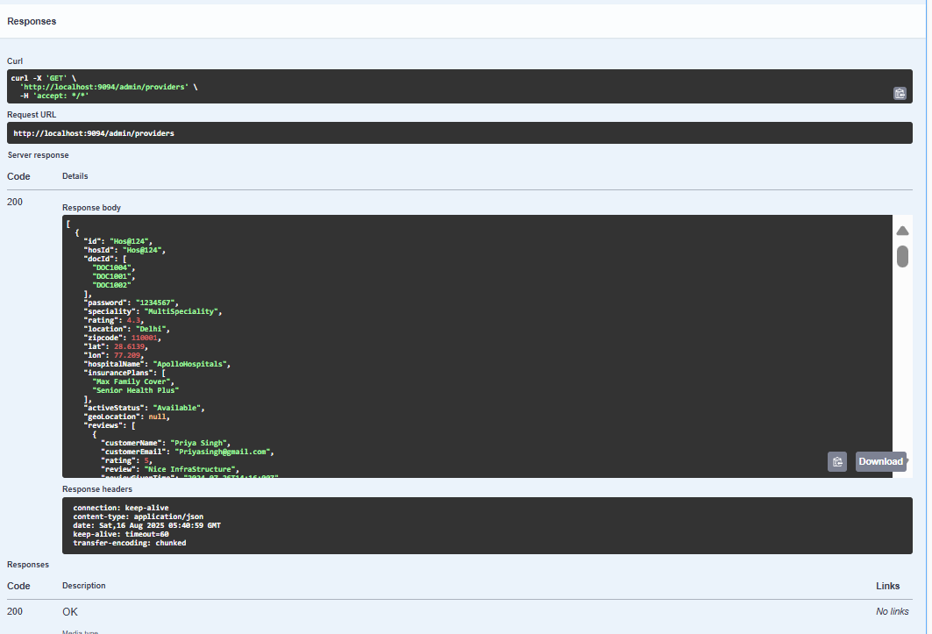

SWAGGER:

LOGIN MICROSERVICE:

LoginController:

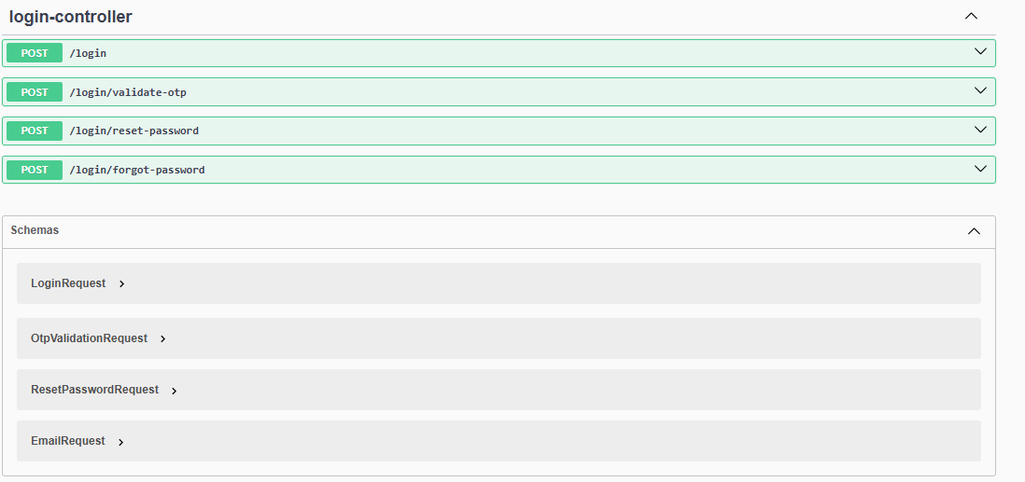

Provider Controller:

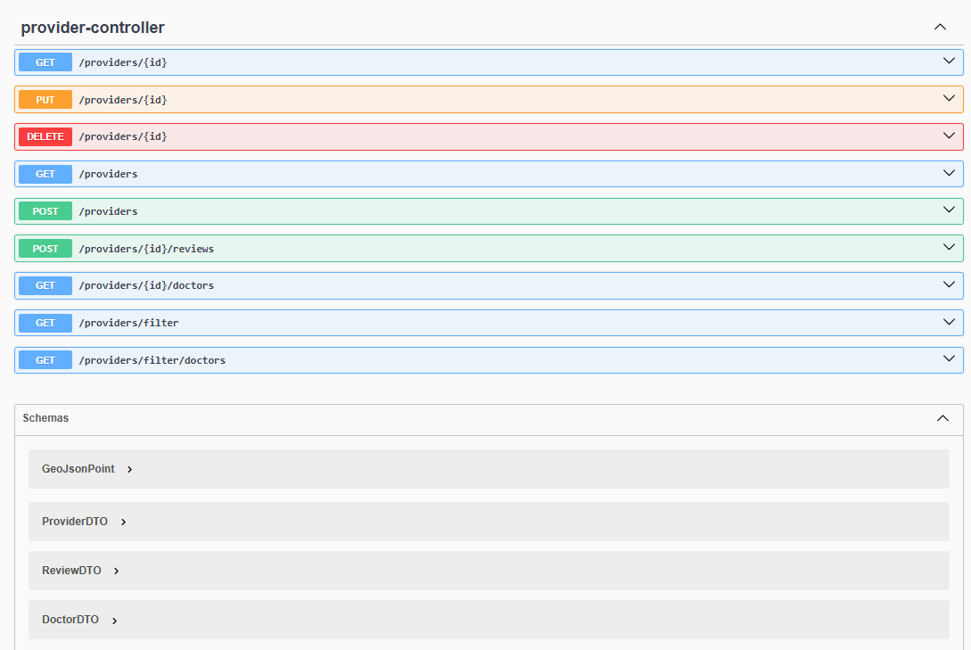

Doctor Controller :

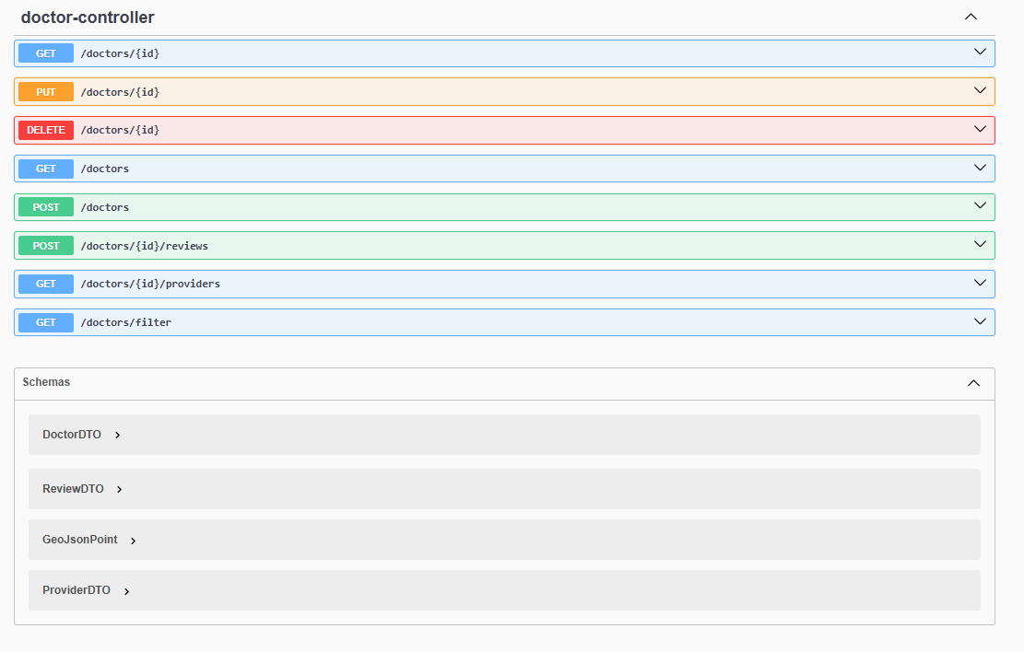

CUSTOMER MICROSERVICE:

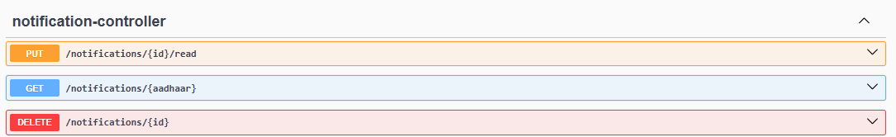

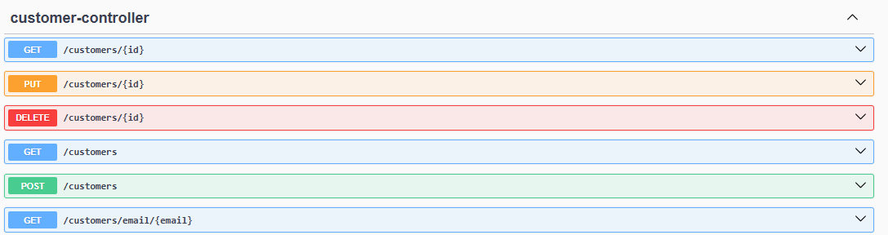

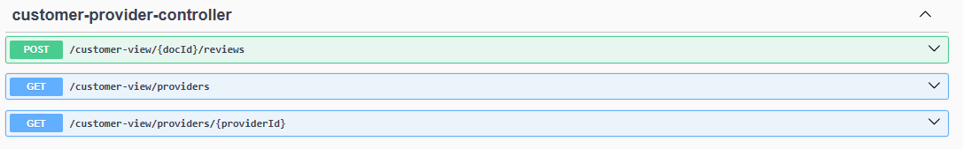

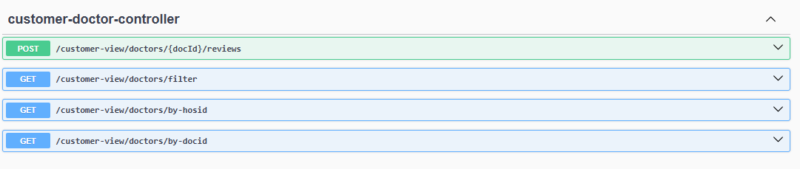

INSURANCE_TEAM MICROSERVICE:

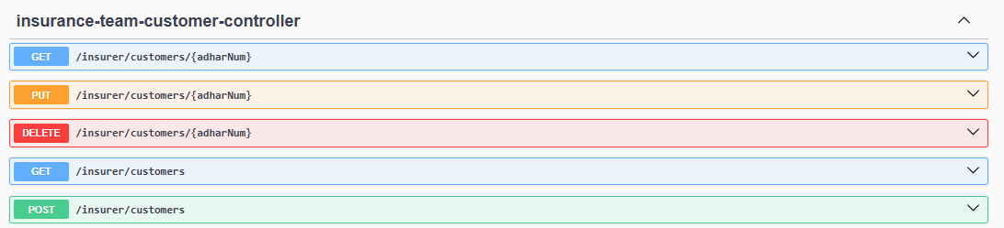

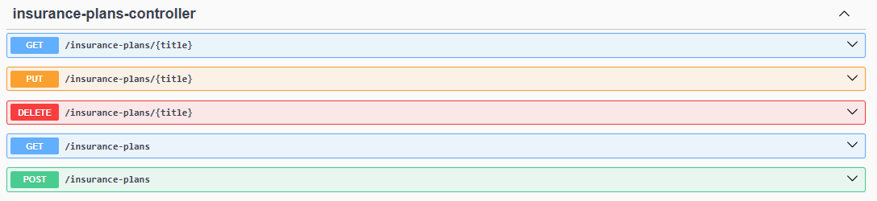

ADMIN MICROSERVICE:

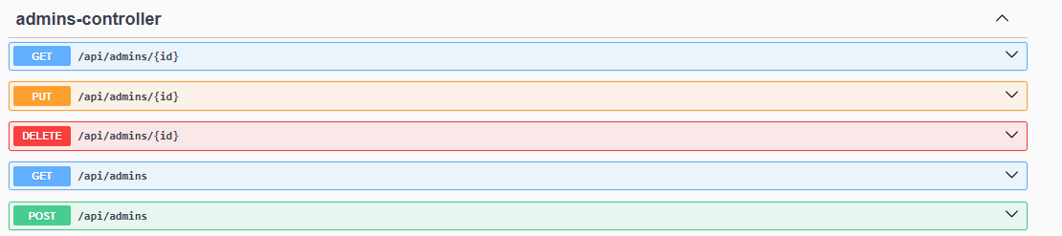

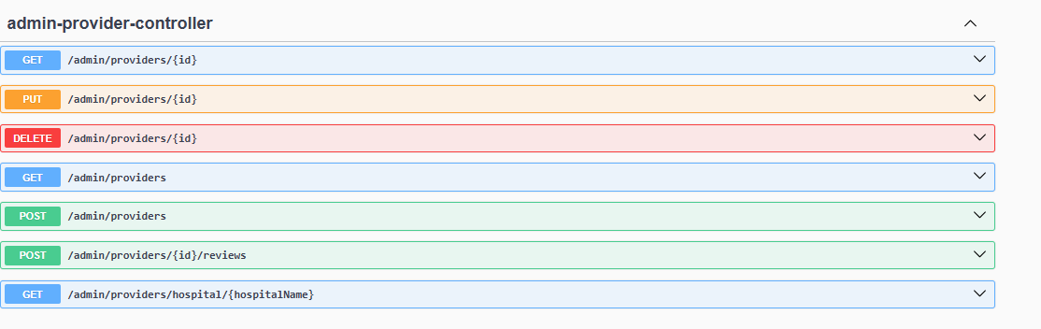

POSTMAN Testing :

